Day 2:

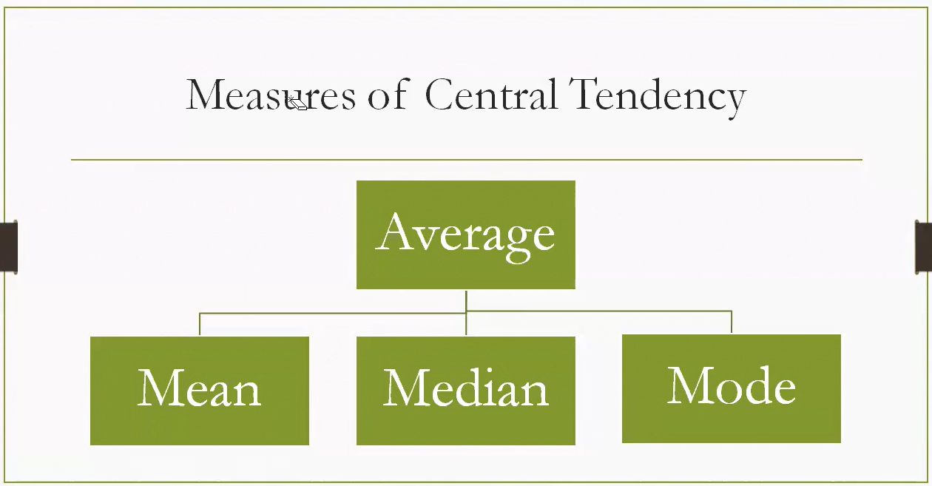

**Measures of Central Tendency**

These are methods to summarize a dataset with a single representative value, often referred to as the **average**. The three main types are:

**1. Mean (Arithmetic Average)**

* **Definition**: Sum of all values divided by the number of values.
* **Use Case**: Best for data without extreme outliers.
* **Example**: For scores [10, 20, 30], the mean is $(10+20+30)/3=20$.

**2. Median**

* **Definition**: The middle value when data is ordered.
* **Use Case**: Ideal when data has outliers or is skewed.
* **Example**: For [10, 20, 100], the median is 20 (middle value).

**3. Mode**

* **Definition**: The value that appears most frequently.
* **Use Case**: Useful for categorical data or identifying common trends.
* **Example**: For [10, 20, 20, 30], the mode is 20.

**🧠 Why It Matters**

Each measure gives a different perspective:

* **Mean** reflects the overall balance.
* **Median** shows the central point.
* **Mode** highlights the most typical value.

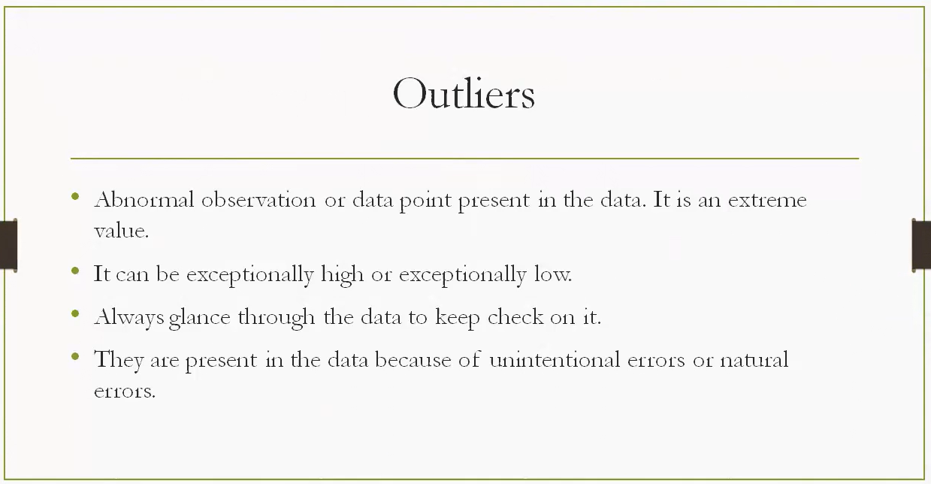

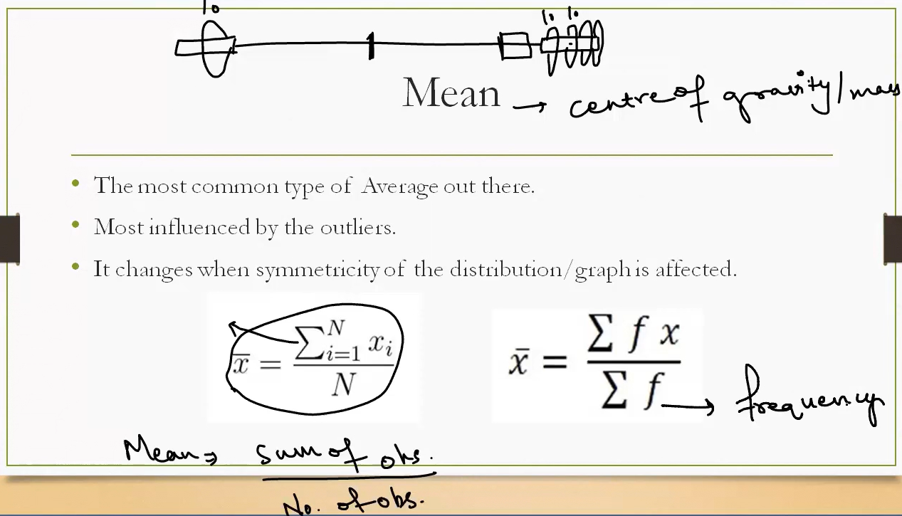

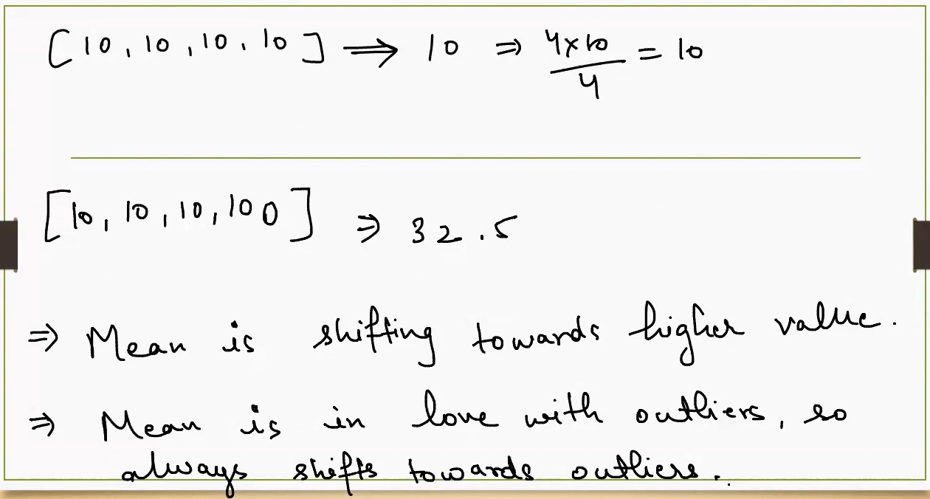

Think of the **mean** as the **center of gravity** of a dataset. If each data point were a weight placed on a number line, the mean is the point where the line would balance perfectly — like a seesaw.

* **Mean** reflects the overall balance.
* This balance could also shift here or there depending on the outliers

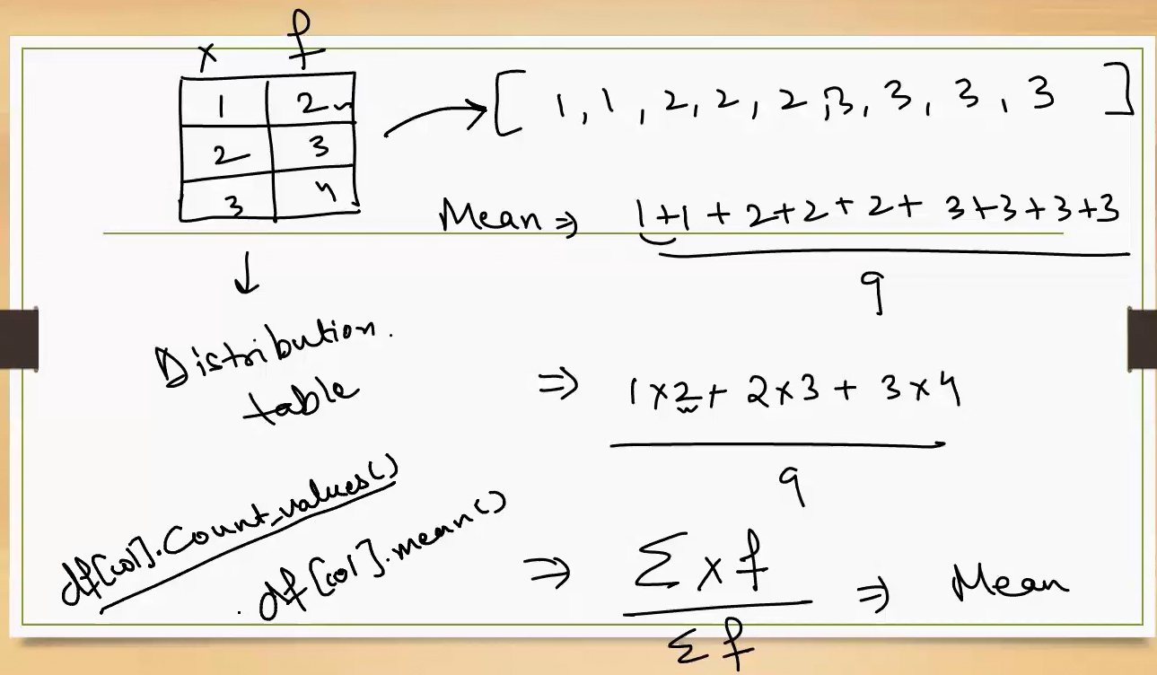

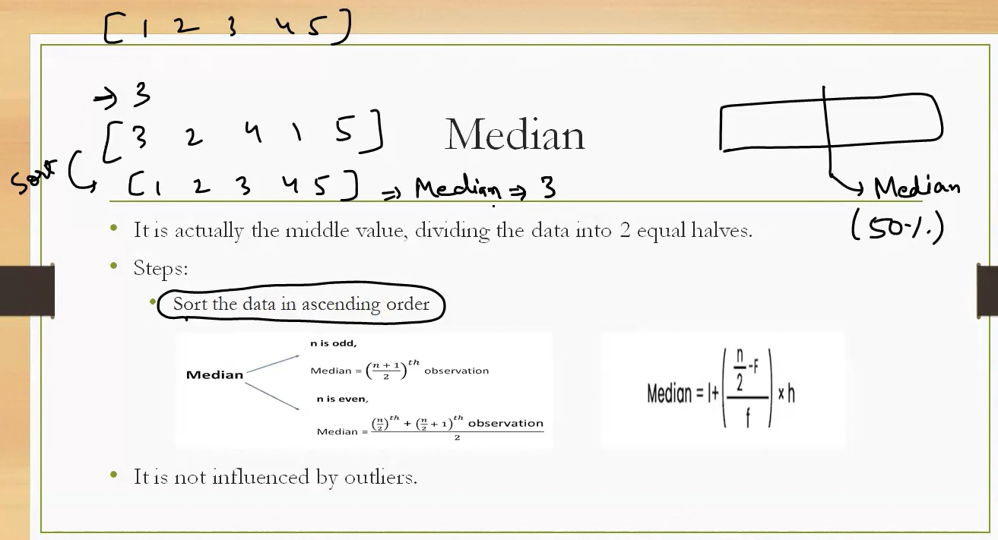

* **Median** shows the central point.

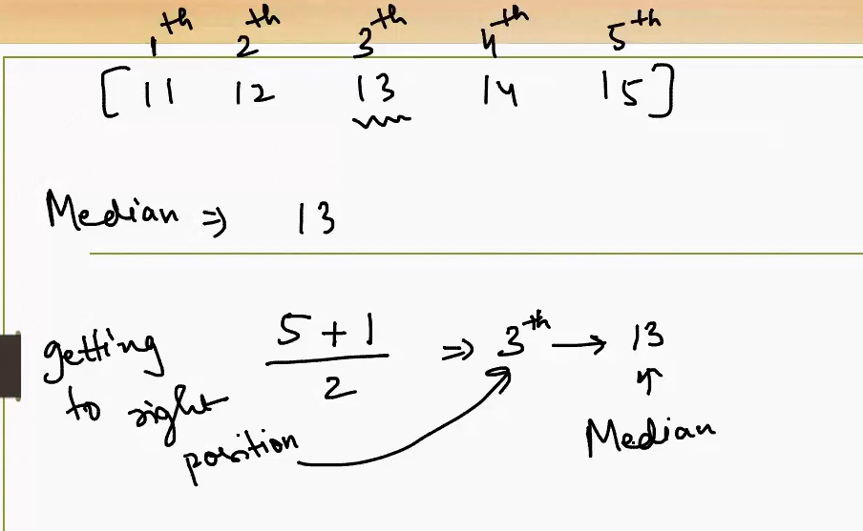

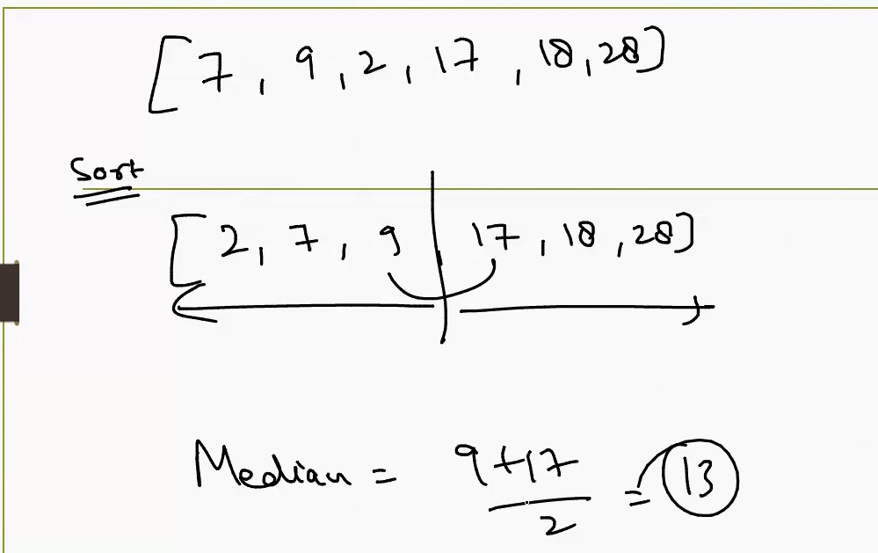

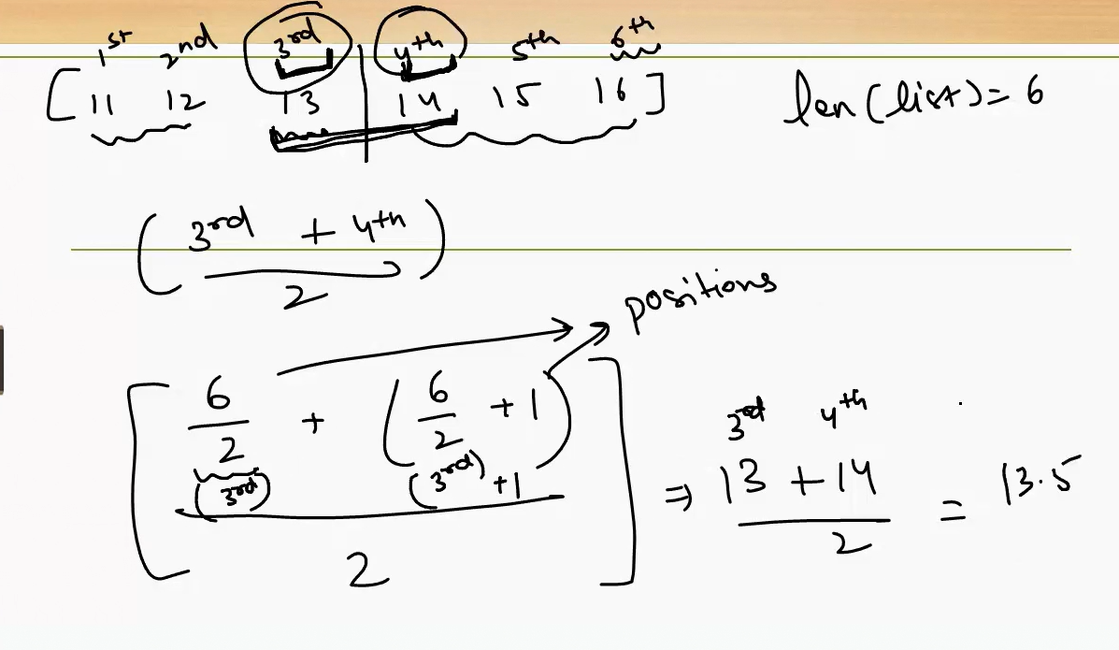

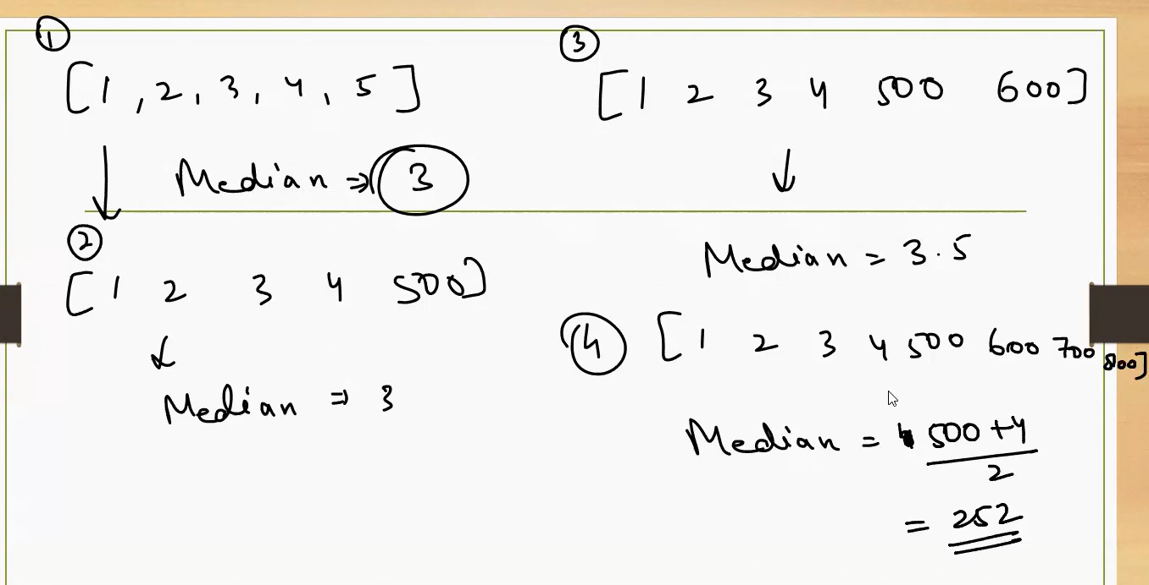

* **Median doesn’t get affected by outliers generally.**
* Very less influenced by outliers
* **Median** shows the central point.

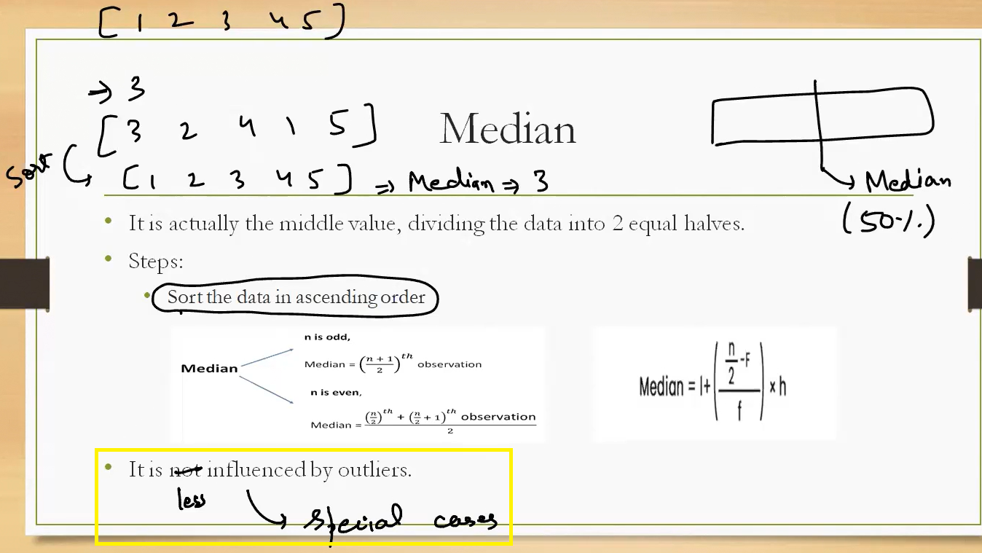

**Mode :**

Most frequently occurring data is called mode.

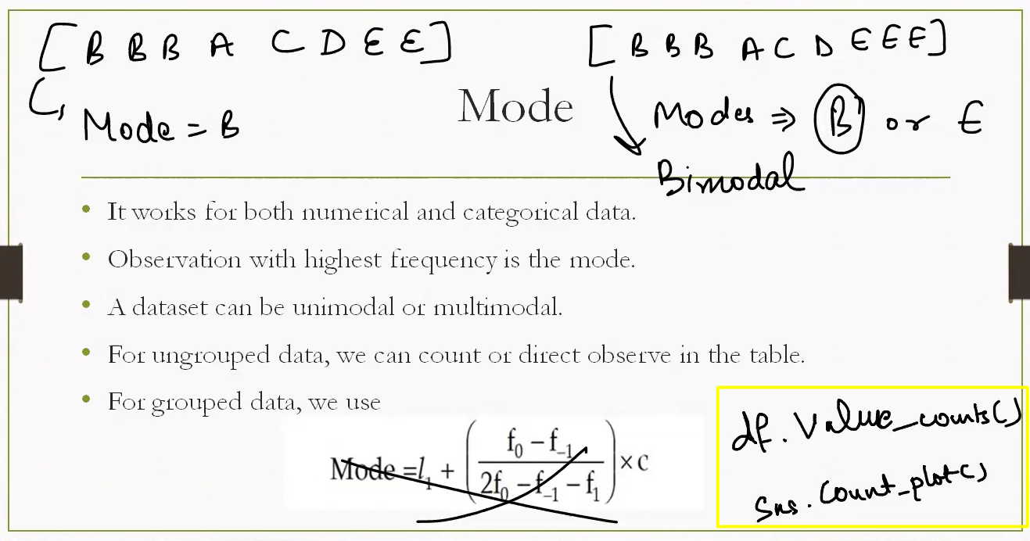

**Imputation of Missing values :**

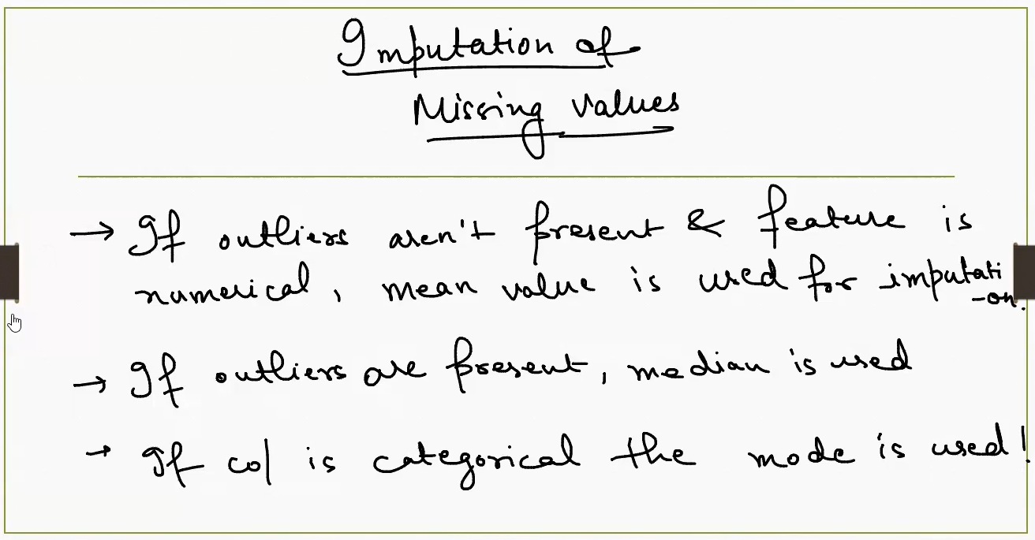

**🧮 What Is Imputation?**

**Imputation** is the process of filling in missing data points in a dataset so that models can be trained without errors or bias due to incomplete data.

**🔍 Decision Logic for Imputation**

**1. Numerical Features Without Outliers → Use Mean**

* **Why**: The mean (average) is a good representative when the data is symmetrically distributed. **If outliers aren’t present then mean is used.**
* **Example**: For heights [160, 165, 170, NaN], impute missing value with mean = 165.

**2. Numerical Features With Outliers → Use Median**

* **Why**: The median is robust to outliers and better reflects the central tendency in skewed data. **If outliers are present then median is used.**
* **Example**: For incomes [30K, 35K, 40K, 1M, NaN], the mean is distorted by 1M, so use the median (35K or 40K).

**3. Categorical Features → Use Mode**

* **Why**: The mode represents the most frequent category, which is often a reasonable guess. **If Column is categorical the mode is used.**
* **Example**: For colors [Red, Blue, Blue, NaN], **impute with "Blue" (most frequent).**

**🧠 Summary Table**

| **Feature Type** | **Outliers Present?** | **Imputation Strategy** | **Why?** |
| --- | --- | --- | --- |
| Numerical | No | Mean | Reflects overall balance |
| Numerical | Yes | Median | Resistant to outliers |
| Categorical | N/A | Mode | Most frequent category |

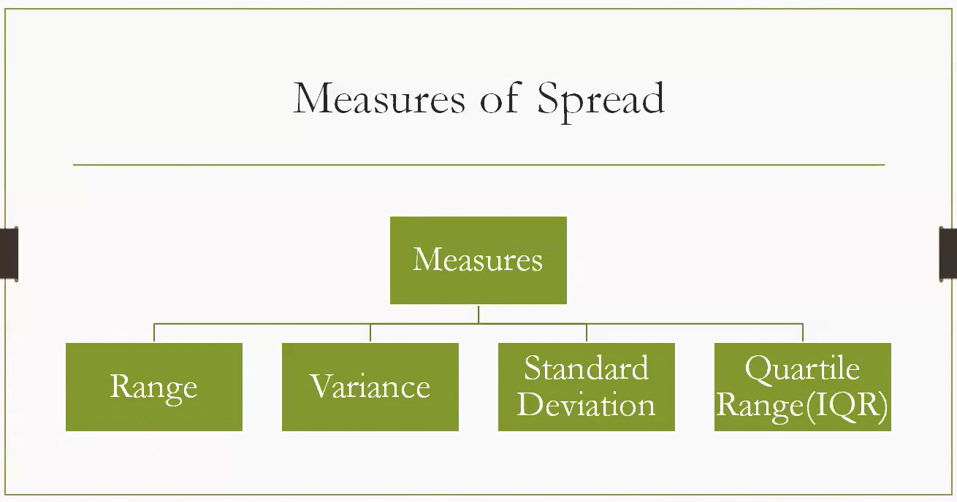

The diagram titled **"Measures of Spread"** outlines key statistical tools used to describe how data values are dispersed or spread out in a dataset. These measures help us understand variability — **how much the data deviates from the center**.

**📊 Measures of Spread — Overview**

These are used to quantify **how scattered** the data points are. Here's a breakdown of each:

**1. Range**

* **Definition**: Difference between the maximum and minimum values.
* **Formula**:
$$\text{Range}=\text{Max}-\text{Min}$$

* **Use Case**: Quick sense of spread, but sensitive to outliers.

**2. Variance**

* **Definition**: Average of squared deviations from the mean.
* **Formula**:
$$\text{Variance}=\frac{1}{n}\sum_{i=1}^{n}{}(x_{i}-\overset{ˉ}{x})^{2}$$

* **Use Case**: Measures how far data points are from the mean.

**3. Standard Deviation**

* **Definition**: Square root of variance.
* **Formula**:
$$\text{SD}=\sqrt{\text{Variance}}$$

* **Use Case**: More interpretable than variance; in same units as data.

**4. Interquartile Range (IQR)**

* **Definition**: Difference between the 75th percentile (Q3) and 25th percentile (Q1).
* **Formula**:
$$\text{IQR}=Q3-Q1$$

* **Use Case**: Robust to outliers; focuses on the middle 50% of data.

**🧠 Why It Matters**

* **Low spread** → data points are close to the center.
* **High spread** → data points are widely scattered.
* Choosing the right measure depends on whether the data has **outliers**, is **skewed**, or needs **robustness**.

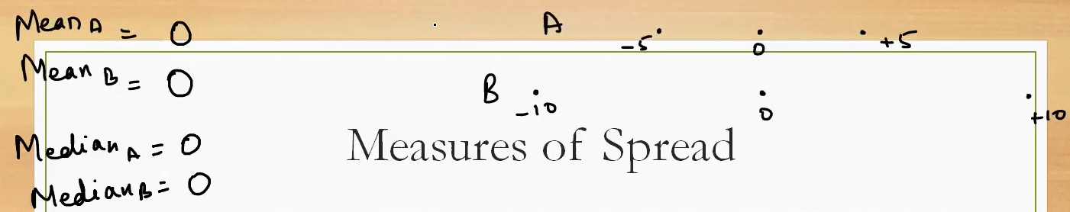

Here the spread is different for the data set, but the Mean & Median for both the data set is same.

But the data set is different hence we need measures of Spread.

This visual illustrates a powerful concept in statistics: **measures of spread** — and how two datasets can have the **same center** (mean and median) but **different variability**.

**📊 What’s Shown in the Diagram**

You have two datasets:

* **Set A**: $[-5,0,+5]$
* **Set B**: $[-10,0,+10]$

Both have:

* **Mean = 0**
* **Median = 0**

But the **spread** — how far the values are from the center — is different.

**⚖️ Why This Matters**

Even though both sets are centered at 0, their **variability** differs:

| **Measure** | **Set A** | **Set B** | **Interpretation** |
| --- | --- | --- | --- |
| Mean | 0 | 0 | Same center |
| Median | 0 | 0 | Same middle value |
| Range | $$5-(-5)=10$$ | $$10-(-10)=20$$ | Set B is twice as spread out |
| Variance | Lower | Higher | Set B has more deviation from mean |
| Standard Deviation | Lower | Higher | Set B is more dispersed |

**🧠 Key Insight**

**Central tendency alone doesn’t tell the full story.** You need measures of spread to understand how **tight or loose** the data is around the center.

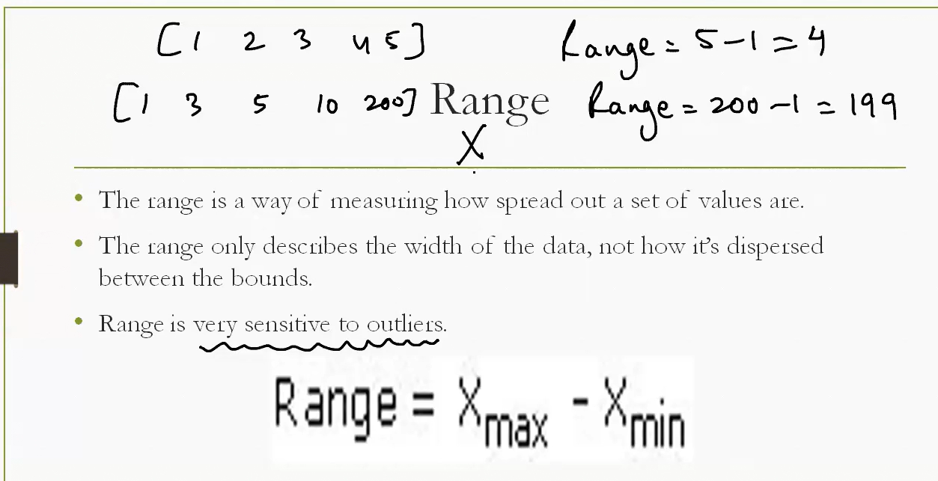

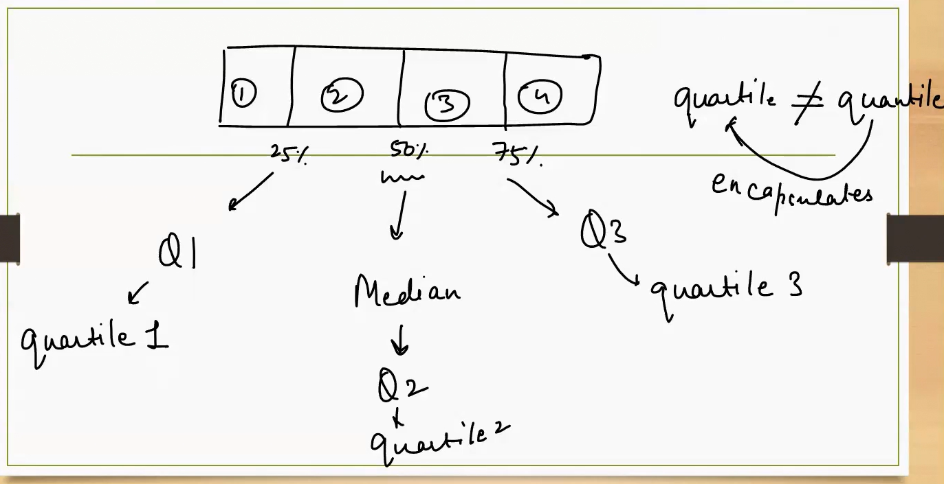

Quartile divides the dataset in 4 equal parts.

**quartiles** in statistics — a way to divide a dataset into four equal parts to understand its distribution. Let’s break it down clearly:

**📦 What Are Quartiles?**

Quartiles split ordered data into **four equal parts**, each containing **25% of the data**:

| **Quartile** | **Symbol** | **Position** | **Meaning** |
| --- | --- | --- | --- |
| Q1 | Quantile 1 | 25% | Lower quartile — 25% of data falls below this point |
| Q2 | Median / Quantile 2 | 50% | Middle value — splits data in half |
| Q3 | Quantile 3 | 75% | Upper quartile — 75% of data falls below this point |

**Key Clarification: Quantile ≠ Quartile**

* A **quantile** is a general term for dividing data into equal-sized intervals (e.g., deciles, percentiles).
* A **quartile** is a **specific type of quantile** that divides data into **four parts**.

So:

* **Quartile** = a region or segment of data.
* **Quantile** = a point or threshold that marks the boundary.

**📌 Visual Interpretation**

Imagine a box divided into four equal segments:

* Each segment holds 25% of the data.
* Q1 marks the end of the first 25%.
* Q2 (Median) marks the halfway point.
* Q3 marks the end of the third 25%.

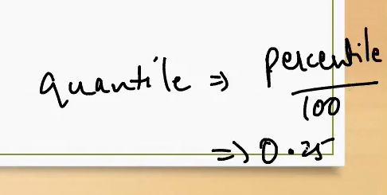

**A *quantile* is a general term for dividing data into equal-sized intervals, while a *quartile* is a specific type of quantile that splits data into four parts. Quartiles are used to summarize the distribution of data, especially its spread and central tendency.**

**📊 Quantile vs. Quartile — Detailed Breakdown**

**🔹 What Is a Quantile?**

* A **quantile** is a cut point that divides a dataset or probability distribution into equal-sized intervals.
* Quantiles are flexible: you can divide data into halves (2-quantiles), quarters (4-quantiles), tenths (10-quantiles), hundredths (percentiles), etc.
* **Examples of quantiles**:
  + **Median** is the 0.5 quantile (50th percentile).
  + **Deciles** divide data into 10 equal parts.
  + **Percentiles** divide data into 100 equal parts.

**🔹 What Is a Quartile?**

* A **quartile** is a specific type of quantile that divides data into **four equal parts**.
* Quartiles are based on **percentiles**:
  + **Q1 (First Quartile)** = 25th percentile
  + **Q2 (Second Quartile)** = 50th percentile = Median
  + **Q3 (Third Quartile)** = 75th percentile
* Quartiles help identify the **spread** and **central tendency** of data.

**📐 Example: Dataset = [5, 7, 8, 12, 13, 14, 18, 21]**

1. **Sorted Data**: Already sorted.
2. **Q2 (Median)**: Middle value = (12 + 13)/2 = **12.5**
3. **Q1**: Median of lower half [5, 7, 8, 12] → (7 + 8)/2 = **7.5**
4. **Q3**: Median of upper half [13, 14, 18, 21] → (14 + 18)/2 = **16**

So:

* **Q1 = 7.5**
* **Q2 = 12.5**
* **Q3 = 16**

These quartiles divide the dataset into four equal parts:

* 25% of data ≤ Q1
* 25% between Q1 and Q2
* 25% between Q2 and Q3
* 25% ≥ Q3

**🧠 Summary Table**

| **Term** | **Definition** | **Example (from dataset)** |
| --- | --- | --- |
| Quantile | General division point in data | 0.25 quantile = Q1 |
| Quartile | Specific quantiles dividing data into 4 parts | Q1 = 7.5, Q2 = 12.5, Q3 = 16 |

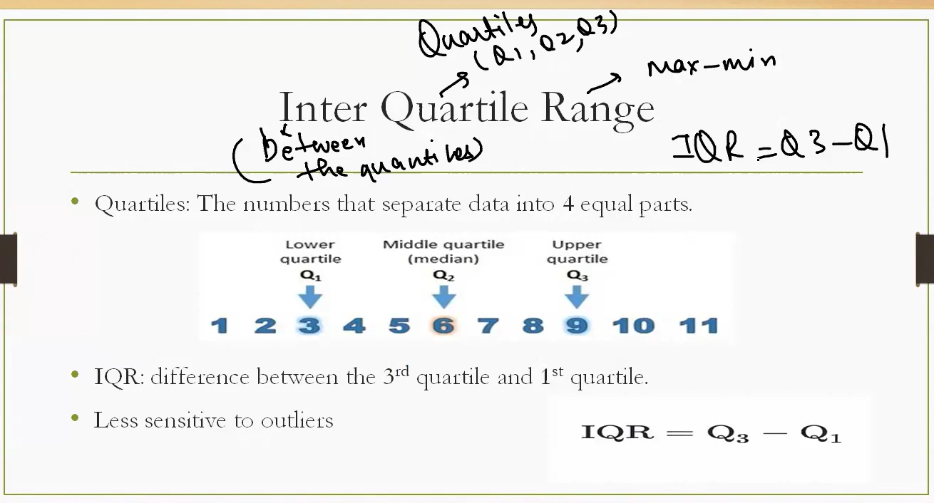

Interquartile Range (IQR) — a key measure of statistical spread that focuses on the middle 50% of a dataset.

**What Are Quartiles?**

* **Quartiles** divide ordered data into **four equal parts**:
  + **Q1 (First Quartile)**: 25% of data falls below this point.
  + **Q2 (Second Quartile / Median)**: 50% of data falls below this point.
  + **Q3 (Third Quartile)**: 75% of data falls below this point.

**📐 What Is Interquartile Range (IQR)?**

* **Definition**: The range between the third and first quartile.
* **Formula**:
$$\text{IQR}=Q3-Q1$$

* **Purpose**: Measures the spread of the **middle 50%** of the data.
* **Advantage**: **Less sensitive to outliers** than range or standard deviation.

**📊 Example from the Diagram**

Given a dataset from 1 to 11:

* **Q1 = 3**
* **Q2 (Median) = 6**
* **Q3 = 9**

Then:

$$\text{IQR}=9-3=6$$

This means the central 50% of the data spans a range of 6 units.

**🧠 Why Use IQR?**

* It helps detect **outliers**: values that fall below $Q1-1.5⋅\text{IQR}$ or above $Q3+1.5⋅\text{IQR}$.
* It’s robust for **skewed distributions** or datasets with extreme values.

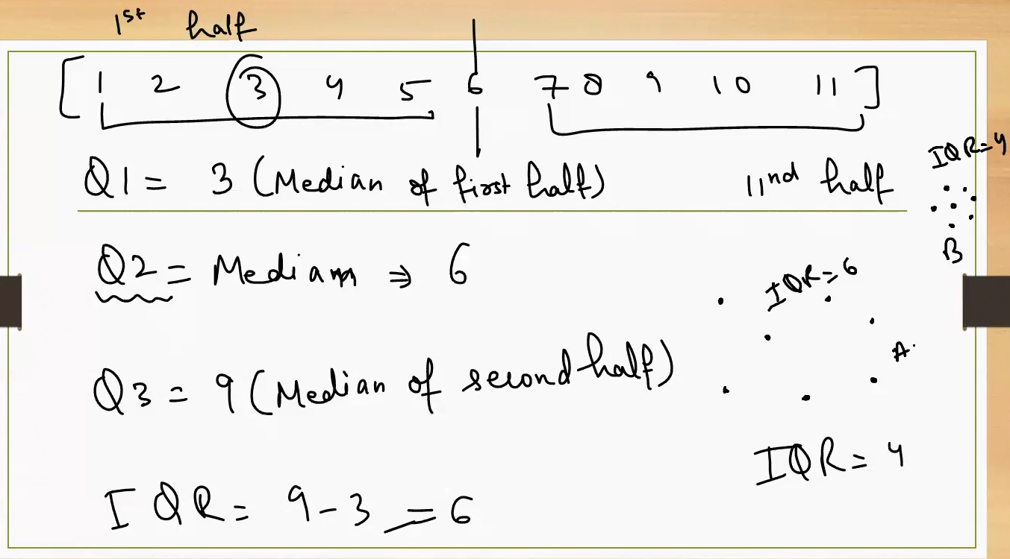

Dataset in B is more dense that Dataset A

**Step-by-Step IQR Calculation**

Given dataset: **[1, 2, 3, 4, 5, 6, 7, 8, 9, 10, 11]**

1. **Sort the data** → already sorted.
2. **Find the Median (Q2)**:
   * Middle value = **6**
3. **Split into two halves**:
   * Lower half: [1, 2, 3, 4, 5]
   * Upper half: [7, 8, 9, 10, 11]
4. **Find Q1 (Median of lower half)**:
   * Q1 = **3**
5. **Find Q3 (Median of upper half)**:
   * Q3 = **9**
6. **Calculate IQR**:

$$\text{IQR}=Q3-Q1=9-3=6$$

**📐 What Does IQR Tell Us?**

* **IQR measures the spread of the middle 50% of data**.
* It’s **robust to outliers** — unlike range or standard deviation.
* Helps in **outlier detection**:
  + Outliers are typically values below $Q1-1.5⋅\text{IQR}$ or above $Q3+1.5⋅\text{IQR}$.

**📈 Visual Comparison (Group A vs Group B)**

* Group A: IQR = 6 → **wider spread**
* Group B: IQR = 4 → **tighter spread**

This shows that **Group A’s middle 50% of data is more dispersed** than Group B’s, even if their medians are similar.

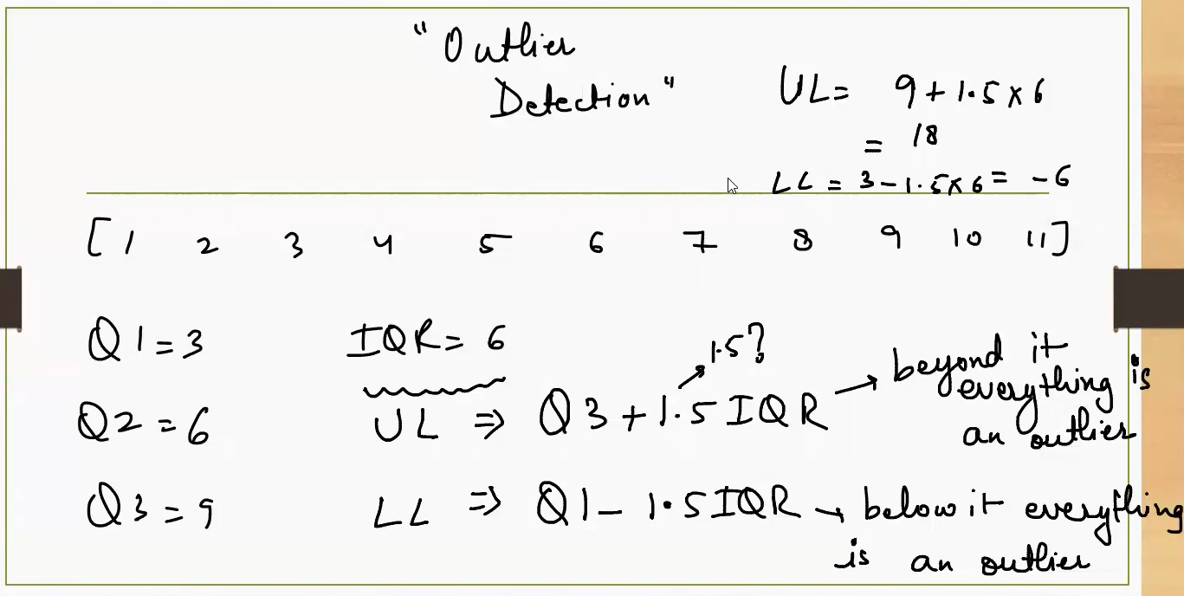

**Step-by-Step Outlier Detection Using IQR**

**1. Calculate Quartiles**

* **Q1 (First Quartile)** = 3
* **Q2 (Median)** = 6
* **Q3 (Third Quartile)** = 9

**2. Compute IQR**

$$\text{IQR}=Q3-Q1=9-3=6$$

**3. Determine Outlier Boundaries**

* **Lower Limit (LL)**:
$$LL=Q1-1.5⋅\text{IQR}=3-1.5⋅6=-6$$

* **Upper Limit (UL)**:

$$UL=Q3+1.5⋅\text{IQR}=9+1.5⋅6=18$$

**4. Interpretation**

* Any value **below -6** or **above 18** is considered an **outlier**.
* Since all values in the dataset are between 1 and 11, **no outliers are present**.

**🧠 Why Use This Method?**

* **IQR-based outlier detection** is **less sensitive to extreme values** than methods using mean and standard deviation.
* It’s ideal for **skewed distributions** or datasets with potential anomalies.

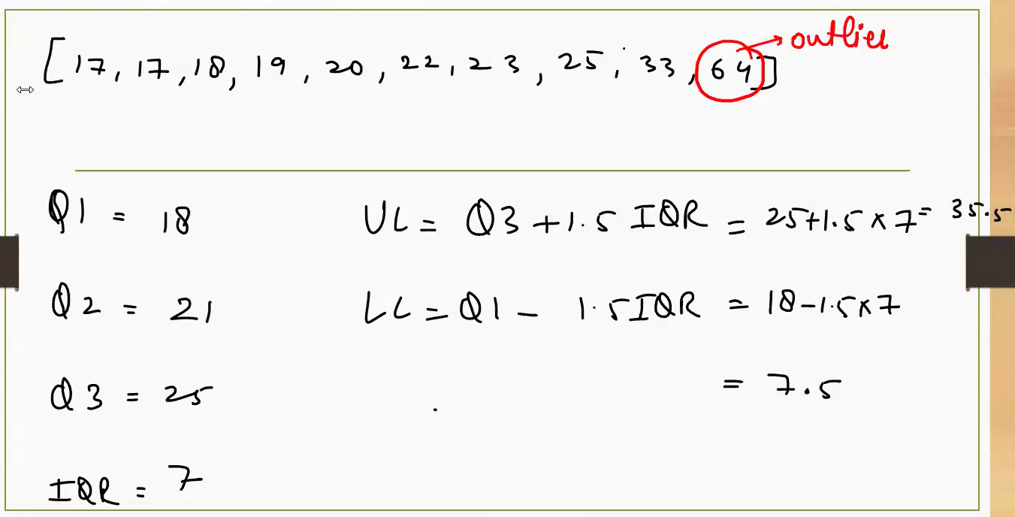

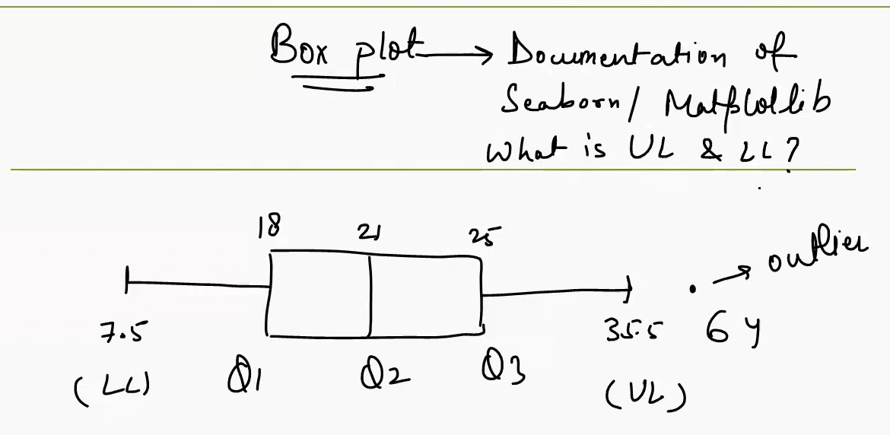

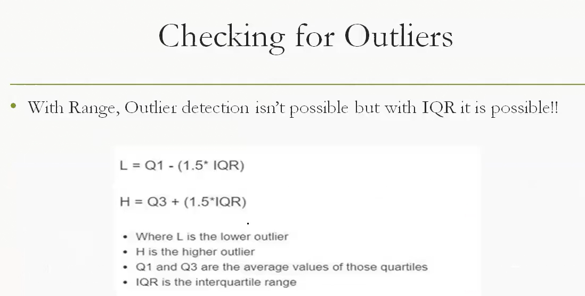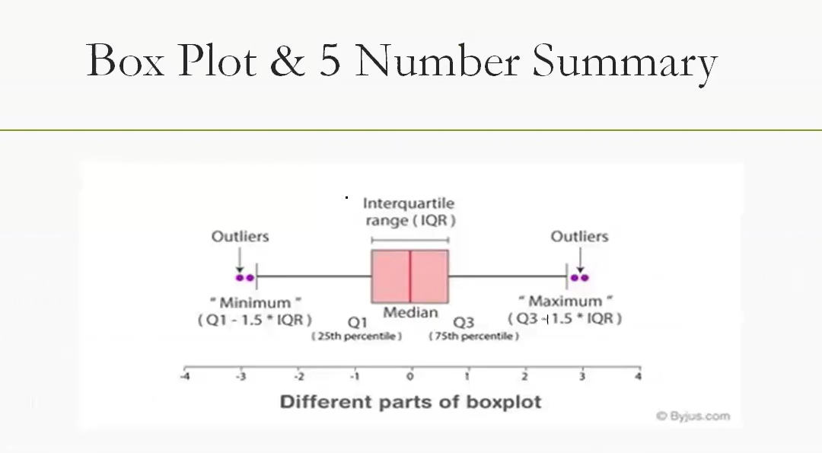

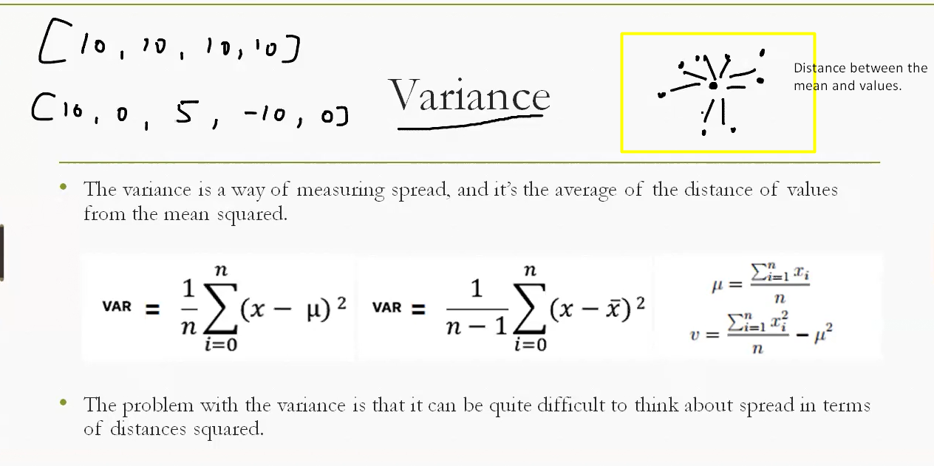

When we capture the distance from mean and you average it out, (post squaring it)you call it a means. It shows the variation.

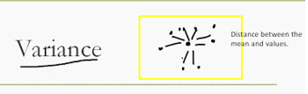

**What Is Variance?**

* **Definition**: Variance quantifies the **average squared distance** between each data point and the mean.
* It tells us **how much the values deviate** from the center.

**🎯 Visual Interpretation**

In the diagram:

* The **central dot** represents the **mean** of the dataset.
* The **surrounding dots** are individual data points.
* The **lines connecting them** show the **distance from each point to the mean**.

This illustrates that:

* If all points are close to the mean → **low variance**.
* If points are far from the mean → **high variance**.

**🧮 Formula**

For a dataset $x_{1},x_{2},...,x_{n}$ with mean $\overset{ˉ}{x}$:

$$\text{Variance}=\frac{1}{n}\sum_{i=1}^{n}{}(x_{i}-\overset{ˉ}{x})^{2}$$

* Each term $(x_{i}-\overset{ˉ}{x})^{2}$ is the **squared deviation** from the mean.
* Squaring avoids cancellation of positive and negative deviations.

**📊 Example**

Dataset: [2, 4, 6, 8, 10] Mean = 6

$$\text{Variance}=\frac{(2-6)^{2}+(4-6)^{2}+(6-6)^{2}+(8-6)^{2}+(10-6)^{2}}{5}=\frac{16+4+0+4+16}{5}=\frac{40}{5}=8$$

So the variance is **8**, indicating moderate spread around the mean.

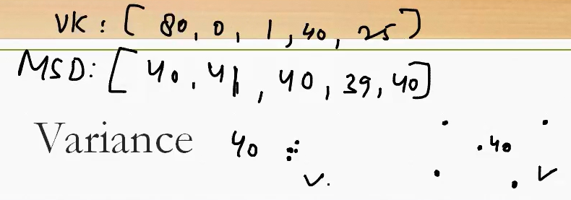

**Datasets**

* **VK (Virat Kohli)**: [80, 0, 1, 40, 25]
  + Highly variable — includes a high score (80) and a zero.
* **MSD (MS Dhoni)**: [40, 41, 40, 39, 40]
  + Very consistent — scores tightly clustered around 40.

**📐 Variance Concept**

* **Variance** quantifies the average squared deviation from the mean.
* A **higher variance** means more fluctuation in performance.
* A **lower variance** means more consistency.

**🧠 Interpretation**

| **Player** | **Mean (approx)** | **Variance (spread)** | **Insight** |
| --- | --- | --- | --- |
| **VK** | ~29 | High | Kohli’s performance fluctuates widely. |
| **MSD** | ~40 | Low | Dhoni’s performance is steady and reliable. |

Even though MSD and VK may have similar averages over time, **VK’s scores swing dramatically**, while **MSD’s are stable** — variance captures this difference.

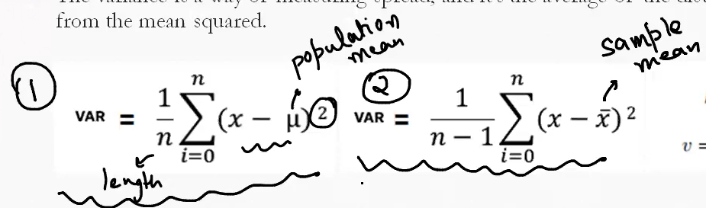

**1. Population Variance**

$$\text{VAR}=\frac{1}{n}\sum_{i=1}^{n}{}(x_{i}-μ)^{2}$$

* **Use when**: You have data for the **entire population**.
* $μ$ is the **population mean**.
* **Denominator** is $n$ (total number of data points).
* **Interpretation**: Measures how much the entire population varies from its true mean.

**📊 2. Sample Variance**

$$\text{VAR}=\frac{1}{n-1}\sum_{i=1}^{n}{}(x_{i}-\overset{ˉ}{x})^{2}$$

* **Use when**: You have a **sample** from a larger population.
* $\overset{ˉ}{x}$ is the **sample mean**.
* **Denominator** is $n-1$— this is called **Bessel’s correction**.
* **Why $n-1$?**: It corrects for bias in estimating population variance from a sample.

**🧠 Summary Table**

| **Type** | **Mean Used** | **Denominator** | **When to Use** |
| --- | --- | --- | --- |
| Population | $$μ$$ | $$n$$ | Whole population data |
| Sample | $$\overset{ˉ}{x}$$ | $$n-1$$ | Subset of population (sample) |

**Scenario: Exam Scores**

Imagine a small class of **5 students** with exam scores:

$$[50,60,70,80,90]$$

We’ll treat this dataset in two ways:

1. As the **entire population** (all students in the class).
2. As a **sample** (just a subset of a larger school).

**🧮 Step 1: Mean**

$$\overset{ˉ}{x}=\frac{50+60+70+80+90}{5}=\frac{350}{5}=70$$

**🧮 Step 2: Squared Deviations**

| **Score** | **Deviation ($x-\overset{ˉ}{x}$)** | **Squared Deviation** |
| --- | --- | --- |
| 50 | -20 | 400 |
| 60 | -10 | 100 |
| 70 | 0 | 0 |
| 80 | +10 | 100 |
| 90 | +20 | 400 |

**Sum of squared deviations = 1000**

**🧮 Step 3: Variance**

**✅ Population Variance**

$${\text{VAR}}_{\text{population}}=\frac{1000}{5}=200$$

**✅ Sample Variance**

$${\text{VAR}}_{\text{sample}}=\frac{1000}{5-1}=\frac{1000}{4}=250$$

**🧠 Why the Difference?**

* **Population variance (200)**: Exact measure of spread because we have **all students’ scores**.
* **Sample variance (250)**: Slightly larger because dividing by $n-1$ corrects for the fact that a sample usually **underestimates variability** in the full population. This adjustment is called **Bessel’s correction**.

**📌 Intuition**

Think of it like this:

* If you only look at a **sample**, you might think the group is more consistent than it really is.
* By dividing by $n-1$, we **inflate the variance slightly** to better approximate the true population variance.

👉 This is why in practice:

* Use **population variance** when you have *all data* (like every student’s score in the class).
* Use **sample variance** when you only have a *subset* (like just one section of the school).

Homework:

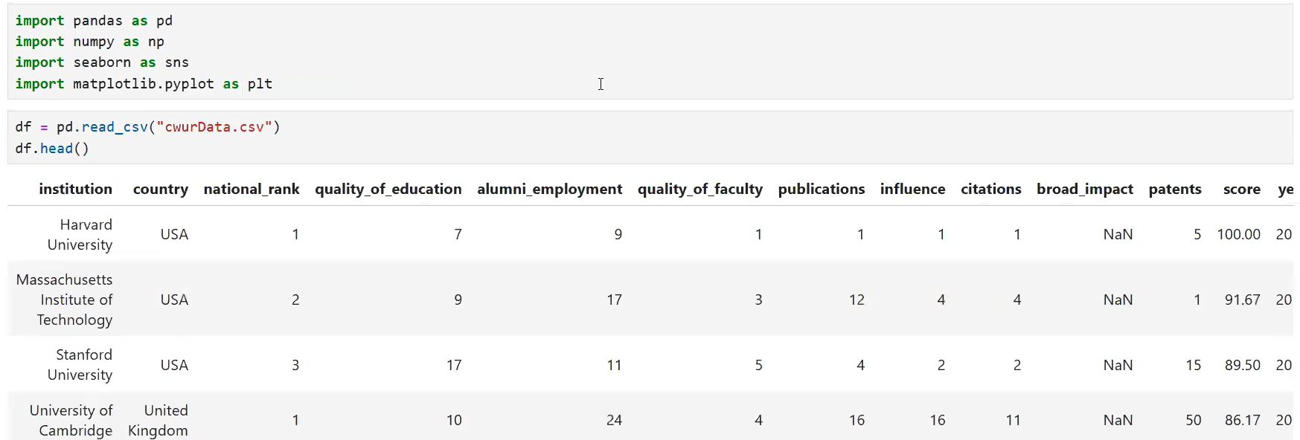

* **First check for missing values**

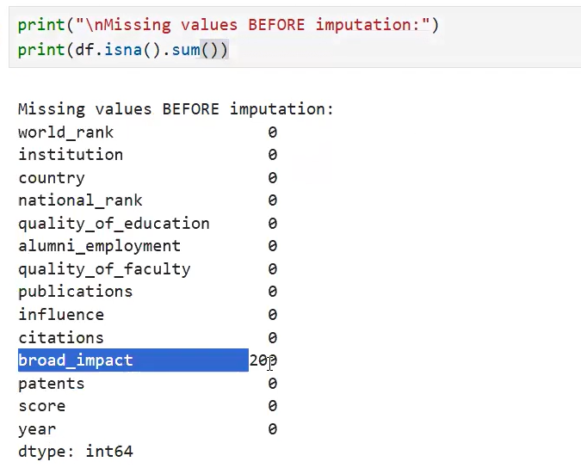

* Create a list of columns which are numerical in nature.

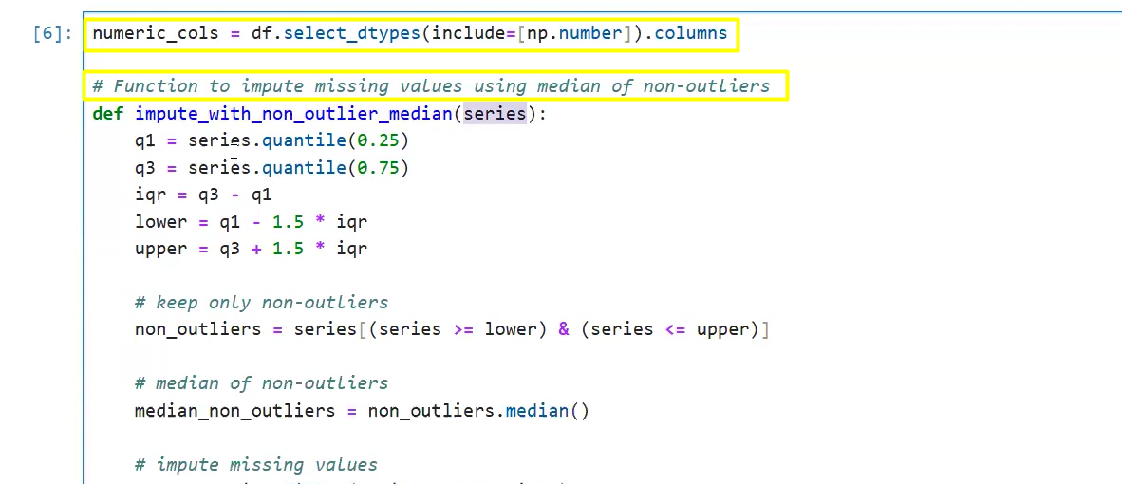

* Fill the missing values

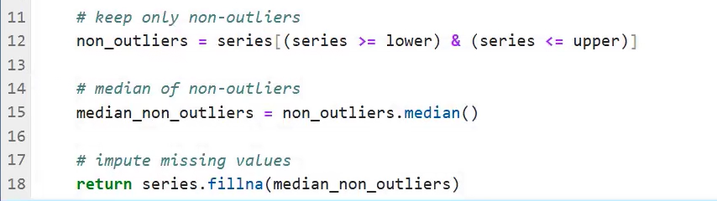

* Apply the above function to replace the missing values on each numerical columns.



* Now for each column calculate, mean, median, mode, reange, IQR, std_dev, variance.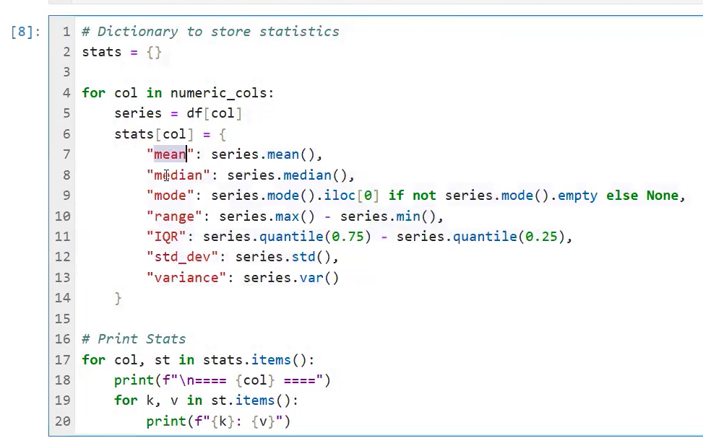
* Result: 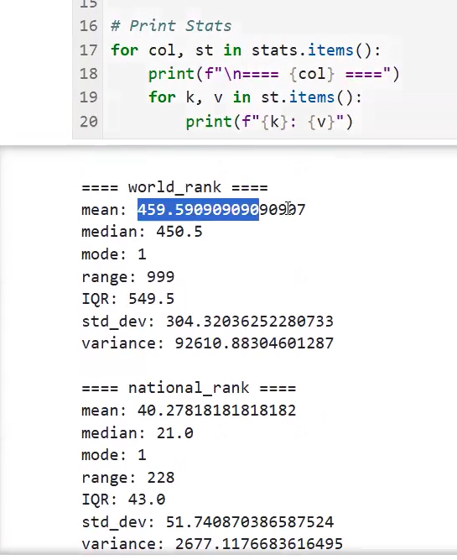
* For numerical columns we have calculated the mean, median, mode…..

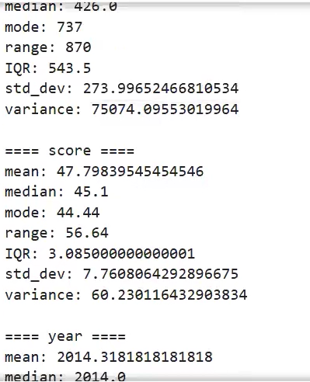

* Finally, you can use it below way:

